**DAILY ONLINE ACTIVITIES SUMMARY**

|  |  |  |  |  |  |  |  |  |
| --- | --- | --- | --- | --- | --- | --- | --- | --- |
| **Date:** | **19/06/2020** | | | | | **Name:** | **NAIPUNYA VINOD NAIK** | |
| **Sem & Sec** | **IV SEM & A SECTION** | | | | | **USN:** | **4AL18CS050** | |
| **Online Test Summary** | | | | | | | | |
| **Subject** | | **MICROCONTROLLER AND EMBEDDED SYSTEMS** | | | | | | |
| **Max. Marks** | | **20** | | **Score** | | | **20** | |
| **Certification Course Summary** | | | | | | | | |
| **Course** | MICROSOFT WINDOWS 10 PRO-HANDS ON TRAINING | | | | | | | |
| **Certificate Provider** | | | **UDEMY** | | **Duration** | | | **4.5 HRS** |
| **Coding Challenges** | | | | | | | | |
| **Problem Statement: 1)** [Write a C Program to Count total set bits in all numbers from 1 to n](https://github.com/orgs/alvas-education-foundation/teams/2nd-year/discussions/129).  2) [Write a C Program to rotate a Matrix by 90 Degree in Clockwise or Anticlockwise Direction. Implement (Both the rotations in single program using switch case statement).](https://github.com/orgs/alvas-education-foundation/teams/2nd-year/discussions/128) | | | | | | | | |
| **Status: EXECUTED** | | | | | | | | |
| **Uploaded the report in Github** | | | | | **YES** | | | |
| **If yes Repository name** | | | | | <https://github.com/naipunya-naik/lockdown-coding/blob/master/C%20CODING/count%20set%20bits_19-06-2020.c>  <https://github.com/naipunya-naik/lockdown-coding/blob/master/C%20CODING/rotate%20matrix_19-06-2020.c> | | | |
| **Uploaded the report in slack** | | | | | **YES** | | | |

Online Test Details: (Attach the snapshot and briefly write the report for the same)

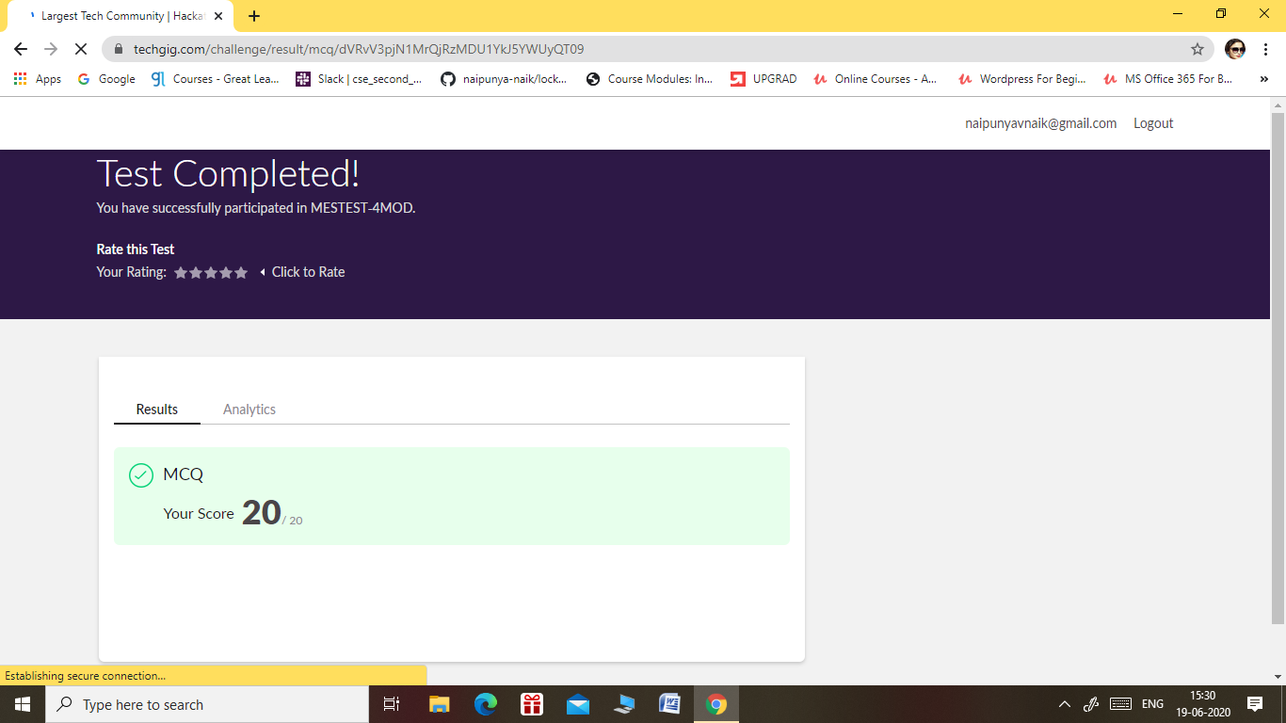

* THE 4TH I.A TEST OF MICROCONTROLLER AND EMBEDDED SYSTEMS WAS CONDUCTED ON 19 JUNE, 2020.
* SUBJECT:- MICROCONTROLLER AND EMBEDDED SYSTEMS
* SYLLABUS:- MODULE 4
* NO.OF QUESTIONS:- 20
* START TIME:- 3.00 PM
* END TIME:- 3.30 PM
* DURATION:- 30 MIN
* EACH QUESTION CARRIED 1 MARK

Certification Course Details: (Attach the snapshot and briefly write the report for the same)

CERTIFICATION COURSE NAME:-

MICROSOFT WINDOWS 10 PRO-HANDS ON TRAINING



Coding Challenges Details: (Attach the snapshot and briefly write the report for the same)

PROBLEM STATEMENT 1:-

[Write a C Program to Count total set bits in all numbers from 1 to n](https://github.com/orgs/alvas-education-foundation/teams/2nd-year/discussions/129)

Top of Form

Bottom of Form

|  |
| --- |
| Given a positive integer n, count the total number of set bits in binary representation of all numbers from 1 to n.  **Examples:** Input: n = 3 Output: 4 Input: n = 6 Output: 9  **Hint:** Read a positive integer (example: 3 indicates range), so u have to consider 1, 2, 3 as the input convert these numbers into binary and count the number of 1 in that (1- 0001, 2- 0010, 3- 0011) number of 1s from all 3 digit is 4 so the answer is 4.  Screenshot (153).png |

GITHUB REPOSITORY LINK:-

<https://github.com/naipunya-naik/lockdown-coding/blob/master/C%20CODING/count%20set%20bits_19-06-2020.c>

PROBLEM STATEMENT 2:-

[Write a C Program to rotate a Matrix by 90 Degree in Clockwise or Anticlockwise Direction. Implement (Both the rotations in single program using switch case statement).](https://github.com/orgs/alvas-education-foundation/teams/2nd-year/discussions/128)

Top of Form

Bottom of Form

|  |
| --- |
| Matrix Rotation by 90 Degree in Clockwise Direction:  Input: Enter the total Number of Rows m: 3 Enter the total Number of Columns: 3 Enter the Elements of the Matrix: 1 2 3 4 5 6 7 8 9 Output: The Given Matrix is: 1 2 3 4 5 6 7 8 9 The Output Matrix After Rotation by 90 Degree in Clockwise Direction is: 7 4 1 8 5 2 9 6 3  Matrix Rotation by 90 Degree in Anticlockwise Direction:  Input: Enter the total Number of Rows m: 3 Enter the total Number of Columns: 3 Enter the Elements of the Matrix: 1 2 3 4 5 6 7 8 9 Output: The Given Matrix is: 1 2 3 4 5 6 7 8 9  The Output Matrix After Rotation by 90 Degree in Clockwise Direction is: 3 6 9 2 5 8 1 4 7  Hint: Steps involved in Matrix Rotation by 90 Degree in Clockwise direction: ⎝ Find the Transpose of the Matrix ⎝ Reverse every rows of the Matrix  Steps involved in Matrix Rotation by 90 Degree in Anti clockwise direction: ⎝ Find the Transpose of the Matrix ⎝ Reverse every columns of the Matrix |

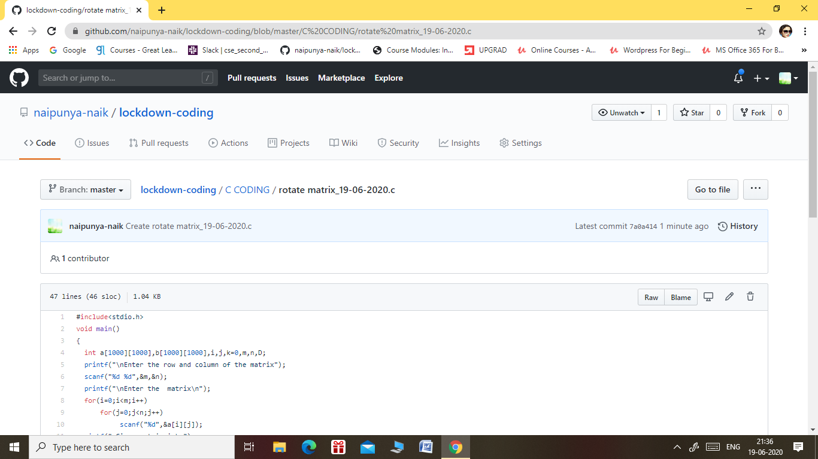

GITHUB REPOSITORY LINK:-

<https://github.com/naipunya-naik/lockdown-coding/blob/master/C%20CODING/rotate%20matrix_19-06-2020.c>